RS 232
Ruhe |  | LSB0 | B1 | B2 | B3 | B4 | B5 | B6 | MSB7 | (P) | Stor | (ST) | Ruhe
startBit
104µs
0

P1.0 TX
9600 Band → 1/9600 1Bit/9600Bit/Sec = 104µs

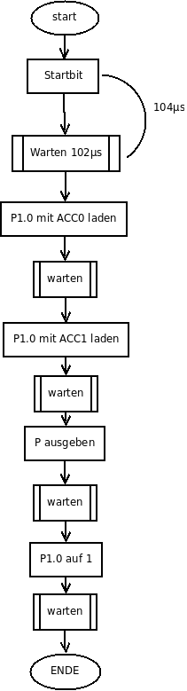
TX EQU P1.0
CSEG AT 00h
jmp _START
CSEG AT 50h
_START:
setb P1.0
clr A
_MAIN:
INC A
call _SENDDATA
jmp _MAIN
_SENDDATA:
CLR P1.0; CLR TX
call _WARTEN
mov C, ACC.0 ;1MZ
mov P1.0,C ;2MZ
call _Warten ;101µs
mov C,ACC.7
mov P1.0, C
call _WARTEN
mov C, P
(cpl C) ; bei ungerader Parität
mov P1.0,C
call _WARTEN
setB P1.0
call _WARTEN
ret
RRC A ; Rotate Right A (Bit 0 im C)
mov P1.0, C
mov R7, #8
_LOOP:
RRC A ; 1MZ
mov P1.0,C ; 2MZ
call _WARTEN ; → 99MZ
DJNZ R7, _LOOP ; 2MZ

